|  |  |  |  |
| --- | --- | --- | --- |
| logo-CvSU-2  Republic of the Philippines  **CAVITE STATE UNIVERSITY**  **Bacoor City Campus**  SHIV, Molino VI, City of Bacoor  **DEPARTMENT OF COMPUTER STUDIES**  **ITEC 106: IT Elective 2 (Web Systems and Technologies 2)**  **Activity Sheet**  **2nd Semester, A.Y. 2021-2022** INTENDED LEARNING OUTCOMES   **After the completion of the unit, students will be able to:**   1. Understand the different functions associated in file manipulation. 2. Write a PHP program that reads and write to a file. | | | |
| **activity 03: PHP FILE MANIPULATION** | | | |
|  | | | |
| DIRECTION  * Write a PHP program that will request input from the user about his/her favorite food and then move the user’s response from one file to another. * Design the interface of the program in HTML and CSS. * Attach your activity worksheet and activity files here. | | | |
| **rubrics for grading:** | | |
|  | | |
| **Category** | **Description** | |
| **Program**  **Execution (25pts)** | Program executes correctly with no syntax or runtime errors. | |
| **Correctness**  **(25pts)** | Program produces correct answers or appropriate results for all  inputs tested. | |
| **Completeness**  **(25pts)** | Program shows evidence of excellent case analysis, and all  possible cases are handled appropriately. | |
| **Logic**  **(25pts)** | Program logic is correct, with no known boundary errors, and  no redundant or contradictory conditions. | |



Republic of the Philippines

**CAVITE STATE UNIVERSITY**

**Bacoor City Campus**

SHIV, Molino VI, City of Bacoor

**DEPARTMENT OF COMPUTER STUDIES**

**ITEC 106: IT Elective 2 (Web Systems and Technologies 2)**

**Activity Sheet**

**2nd Semester, A.Y. 2021-2022**

|  |  |
| --- | --- |
| **Name: Nommel Isanar L. Amolat** | **Date: April 28, 2022** |
| **Course/Yr&Section: BSIT 4-3** | **Score:** |

|  |
| --- |
| **screenshot** |
|  |

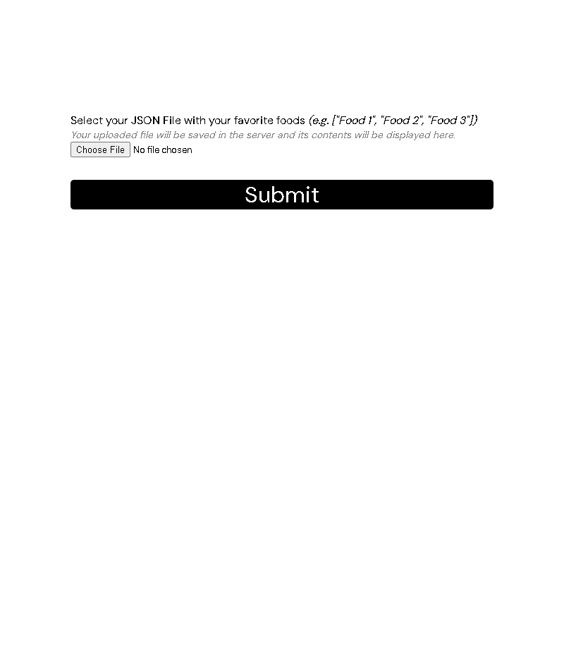

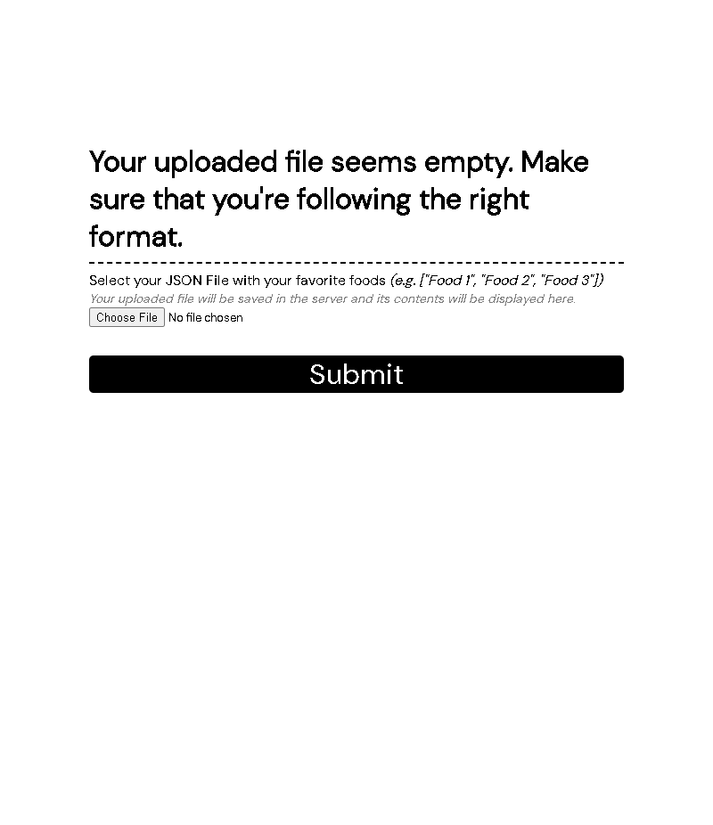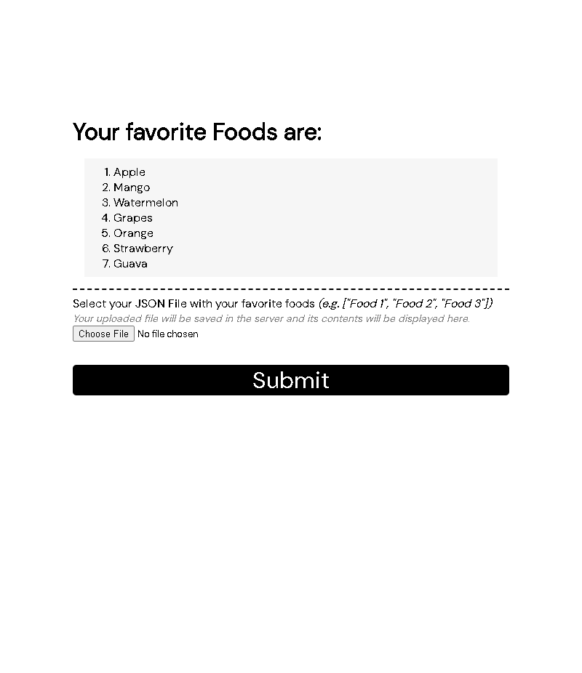

|  |
| --- |
| **source code** |
|  |

/* style.css */

@import "https://fonts.googleapis.com/css2?family=DM+Mono&family=DM+Sans&display=swap";

* {

    margin: 0;

    padding: 0;

    box-sizing: border-box;

    /* font-size: 11pt; */

    font-family: 'DM Sans', sans-serif;

}

body {

    /* text-align: center; */

}

#main-content {

    width: 75%;

    max-width: 640px;

    margin-top: 10em;

    margin-bottom: 10em;

    /* border: 1px solid red; */

    margin-left: auto;

    margin-right: auto;

}

#foods {

    background: rgba(128, 128, 128, 0.07);

    margin: 1em;

    padding: 0.5em;

}

li {

    margin-left: 2em;

}

.hint {

    display: block;

    color: grey;

    font-size: 0.9em;

}

button[type=submit] {

    display: block;

    width: 100%;

    margin-top: 1em;

    font-size: 2em;

    color: white;

    background: black;

    border: none;

    border-radius: 5px;

    cursor: pointer;

}

button[type=submit]:hover {

    color: black;

    background: rgba(0, 0, 0, 0.199);

}

br {

    display: block;

    content: "";

    border-bottom: 0.15em dashed black;

    margin-top: 0.5em;

    margin-bottom: 0.5em;

}

<!-- index.php -->

<?php

    define("UPLOADS_DIR",  __DIR__);

    $submitted = $_REQUEST["submit"] ?? false;

    $filePath = UPLOADS_DIR . "/foods.json";

    $foods = [];

    if($submitted) {

        move_uploaded_file($_FILES["file"]["tmp_name"], $filePath);

    }

    if(file_exists($filePath)) {

        $contents = trim(file_get_contents($filePath));

        if(strlen($contents) > 1)

            $foods = json_decode(file_get_contents($filePath), true) ?? [];

    }

?>

<!DOCTYPE html>

<html lang="en">

<head>

    <meta charset="UTF-8">

    <meta http-equiv="X-UA-Compatible" content="IE=edge">

    <meta name="viewport" content="width=device-width, initial-scale=1.0">

    <link rel="stylesheet" href="style.css">

    <title>BSIT 4-3 | ITEC 106 | Laboratory Activity 3 | PHP File Manipulation</title>

</head>

<body>

    <div id="main-content">

        <?php if(count($foods) > 0) { ?>

            <h1>Your favorite Foods are:</h1>

            <ol id="foods">

                <?php foreach($foods as $key => $food) { ?>

                    <li><?= $food ?></li>

                <?php } ?>

            </ol>

            <br>

        <?php } else if (file_exists($filePath)) { ?>

            <h1>Your uploaded file seems empty. Make sure that you're following the right format.</h1>

            <br>

        <?php } ?>

        <form enctype="multipart/form-data" action="./" method="post">

            <label for="file">Select your JSON File with your favorite foods <i>(e.g. ["Food 1", "Food 2", "Food 3"])</i></label>

            <i class="hint">Your uploaded file will be saved in the server and its contents will be displayed here.</i>

            <input type="hidden" name="MAX_FILE_SIZE" value="30000" />

            <input type="file" name="file" id="file" accept=".json">

            <button type="submit" name="submit" value="1">Submit</button>

        </form>

    </div>

</body>

</html>